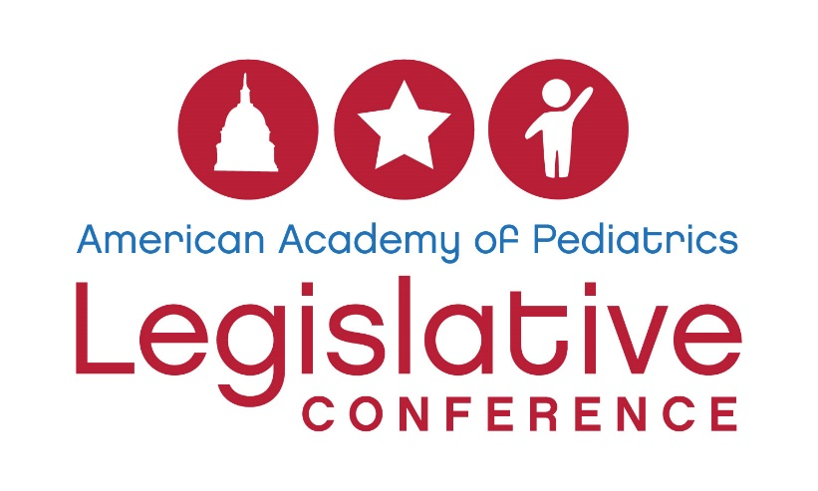
The 2017 conference will also include a Global Child Health Advocacy Track. All attendees who participate in the track will take part in the overall conference agenda while also learning specific skills and legislative topics relevant to global child health. There will also be networking opportunities for track participants to meet other pediatricians interested in global health, global health partners from other organizations, and congressional staffers focused on foreign affairs.
This scholarship will cover the $575 conference fee and provides a $500 stipend to cover travel and hotel expenses.
Deadline to apply: Please complete the following questions and submit your application to LegislativeConference@aap.org by Tuesday, January 31, 2017
Applicant information
Name:
Email:
AAP member ID:
City/state:
Title/institutional affiliation:
Training status (please check one):
Medical student:
Resident:
Fellowship Trainee:
Early-Career Physician (in your first 10 years of practice):
Practicing Pediatrician:
If medical student, academic institution:
If resident or fellowship trainee, residency/fellowship program:
If physician, AAP chapter:
By checking here, I indicate that I have cleared my calendar and if awarded this scholarship, I will be able to attend Legislative Conference in Washington, DC, April 23 – 25, 2017:

Scholarship questions (all applicants must complete the questions)
Describe your interest in global child health advocacy (250 words or less):

What advocacy training have you received through the national AAP or from your AAP chapter? (100 words or less)

Explain your commitment to parlaying what you learn during Legislative Conference into action when you return home: (250 words or less)

How will you partner with your chapter and/or training program in these efforts? (250 words or less)

Please note: The Legislative Conference Scholarship Review Committee reserves the right to ensure applicants represent a diverse geographic range.

