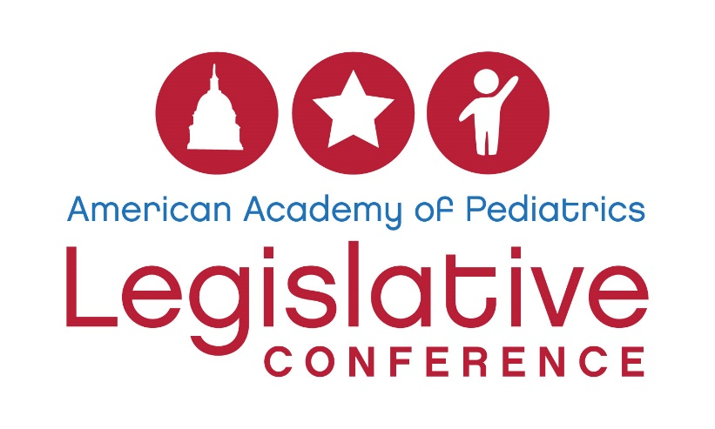
Please complete the following questions and submit your application to LegislativeConference@aap.org by Wednesday, January 18, 2017.
Information on 2017 Legislative Conference Registration Scholarships: Please note this application is for three separate types of scholarship opportunities for the 2017 AAP Legislative Conference on April 23 - 25, 2017, in Washington, DC. For more information on the conference, please visit aap.org/legcon.
- The AAP Committee on Federal Government Affairs is offering 10 scholarships to AAP members in good standing who are medical students, residents, fellowship trainees or practicing pediatricians. This scholarship will cover the $575 registration cost. Lodging and travel expenses are not covered by the scholarship.
- The AAP Section on Pediatric Trainees is offering two scholarships to AAP members in good standing who are medical students, residents or fellowship trainees. This scholarship will cover the $575 registration cost. Lodging and travel expenses are not covered by the scholarship.
- The AAP Section on Early Career Physicians is offering two scholarships to AAP members in good standing who are early career physicians (in their first 10 years of practice). This scholarship will cover the $575 registration cost. Lodging and travel expenses are not covered by the scholarship.
Deadline to apply: Wednesday, January 18, 2017.
Please note: Those applying for the 2017 Advocacy Training Grants through the AAP Community Pediatrics Training Initiative (CPTI) will be considered for the COFGA, SOPT and SOECP scholarships (as eligible) if they are not funded through CPTI. CPTI applicants do not need to submit this application to be eligible for those scholarships.
Applicant information
Name:
Email:
AAP member ID:
City/state:
Title/institutional affiliation:
Which scholarship are you applying to? (Please check or circle all that apply):
AAP Committee on Federal Government Affairs scholarship:
AAP Section on Pediatric Trainees scholarship:
AAP Section on Early Career Physicians scholarship:
Training status (please check one):
Medical student:
Resident:
Fellowship Trainee:
Early-Career Physician (in your first 10 years of practice):
Practicing Pediatrician:
If medical student, academic institution:
If resident or fellowship trainee, residency/fellowship program:
If physician, AAP chapter:
By checking here, I indicate that I have cleared my calendar and if awarded this scholarship, I will be able to attend Legislative Conference in Washington, DC, April 23 – 25, 2017:
Scholarship questions (all applicants must complete the questions)
Describe your interest in advocacy (250 words or less):

What advocacy training have you received through the national AAP or from your AAP chapter? (100 words or less)

Explain your commitment to parlaying what you learn during Legislative Conference into action when you return home: (250 words or less)

How will you partner with your chapter and/or training program in these efforts? (250 words or less)

Please note: If chosen to receive a scholarship, you may be asked to write about your experience for a newsletter article or an online discussion forum. In addition, based upon the number of applications received, the Legislative Conference Scholarship Review Committee reserves the right to ensure applicants represent a diverse geographic range.

