International Children’s Day 2017
June 1, 2017
Pediatrician Advocacy Toolkit

International Children's Day is a global celebration of the rights and well-being of children residing in different parts of the world.
The American Academy of Pediatrics (AAP) is using the day, on June 1, as an opportunity for pediatricians to speak up in the media, with Congress and on social media to support the needs of immigrant and refugee children.

Whether opposing the harmful Executive Orders that have targeted immigrants and refugees to your legislators, referencing the Academy’s recent policy opposing child and family detention, or elevating patient stories, pediatrician voices can play a critical role by sharing messages on the need to protect, nurture and support these vulnerable children and families.

Please consider:
- writing an op-ed, letter-to-the-editor or blog about any of these topics
- sharing messages on social media to urge your federal legislators to support immigrant children, and/or to share personal stories about your immigrant or refugee patients
- reaching out to your federal legislators urging them to support policies that protect immigrant children

If you do take part in any of these activities—please drop us a line and let us know by emailing kids1st@aap.org and entering “International Children’s Day” in the subject line.

Use your Voice to Speak up to Congress
In light of impact the President's Executive Orders are having on immigrant children and families, we encourage you to make your voice heard with your federal legislators. Below, we offer the following messages to assist with letters or phone calls to your Senators and Members of Congress.
Here is the directory for U.S. Representatives and here is the directory for U.S. Senators. Their email addresses and office contact information can be found on their websites.
- As a pediatrician, I care for the health and well-being of all children—no matter where they or their parents were born.
- Immigrant families are our neighbors, they are part of every community, and they are our patients.
- Children do not immigrate, they flee. They are coming to the U.S. seeking safe haven in our country and they need our compassion and assistance.
- Far too many children in this country live in constant fear that they or their parents will be taken into custody or deported. When children are scared, it can impact their health and development.
- Immigrant children and families are an integral part of our communities and our nation, and they deserve to be cared for, treated with compassion, and celebrated. Most of all, they deserve to be healthy and safe.
- The Executive Orders signed by President Trump are harmful to immigrant and refugee children and families throughout our country.
- Many of the children who will be most affected by these Executive Orders are the victims of unspeakable violence and have been exposed to trauma. These children are vulnerable, scared and deserving of our compassion.
- Many other children who have been affected by the Executive Orders are legal, U.S. citizens. The fear and anxiety they live with each day is affecting their short- and long-term health and their ability to go to school. All children deserve better.
- As a pediatrician and a constituent, I stand with the immigrant families I care for and urge you to oppose President Trump’s Executive Orders.

Speak up on Social Media to Protect Immigrant Children
Please consider sharing why it is important to protect immigrant children and families on social media on June 1st, International Children's Day.
To emphasize messages opposed to detention, please use #CareNotCárceles, a bilingual hashtag that means “care not prisons.” All other messages can use #PutKids1st to emphasize the general importance of elevating children as part of the online conversation. There is not an official widely used hashtag for the day itself.
- On International Children’s Day, I stand for health and well-being of all children, no matter where they or their parents were born. #PutKids1st
- On International Children’s Day, I….{insert why you stand for immigrant/refugee children}
- Pediatricians reflect on their experiences caring for immigrant kids, via @healthychildren: http://ow.ly/xona309GbAR #PutKids1st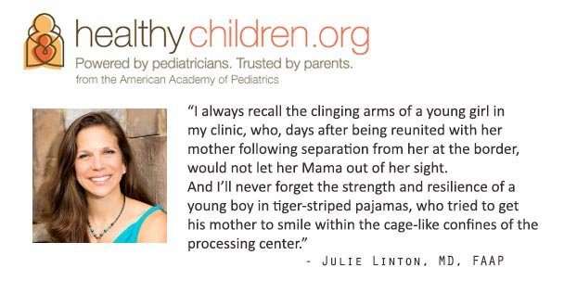
- Many immigrant families are afraid to access key nutrition programs like WIC @guardian: http://ow.ly/rf4Y30bQgXT #PutKids1st
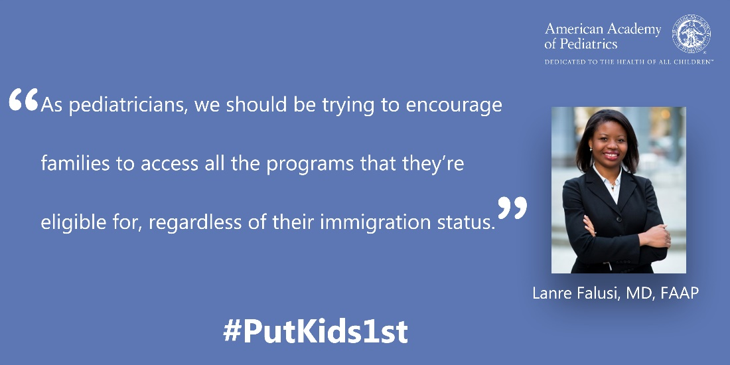
- Immigrant children should be treated with dignity & respect, not detained. http://ow.ly/mu0630bQnrE #CareNotCárceles
- Pediatricians oppose any proposal to separate immigrant children & families: http://ow.ly/POBL309AksH #PutKids1st
- Children should be cared for, not caged. Dr. Alan Shapiro on the harms of detention: http://ow.ly/aYM430bQw5j #CareNotCárceles
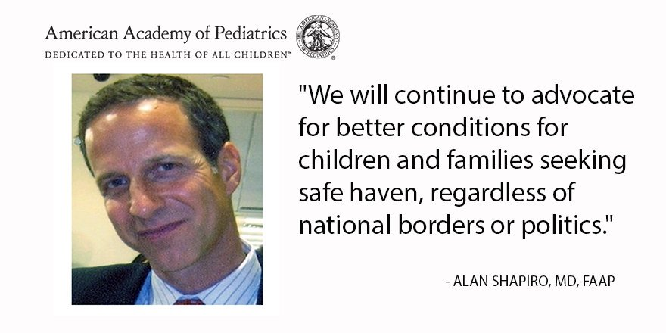
- Immigrant children need our compassion & care. http://ow.ly/oIFU309Okk1 #CareNotCárceles #PutKids1st
- Children shouldn't be exposed to conditions that could re-traumatize them, including detention. http://ow.ly/oIFU309Okk1 #CareNotCárceles
- A pediatrician in Kentucky speaks out about the impacts of #toxicstress on immigrant kids: https://www.youtube.com/watch?v=0slzlmb_KUs #PutKids1st
- A New Mexico pediatrician’s plea: Inhumane immigration policies are bad for child health: http://ow.ly/uM1B30c2NAR #PutKids1st
- A pediatrician in training writes on the devastating impact of deportation on immigrant kids. #CareNotCárceles http://ow.ly/V2qT30bQzdl
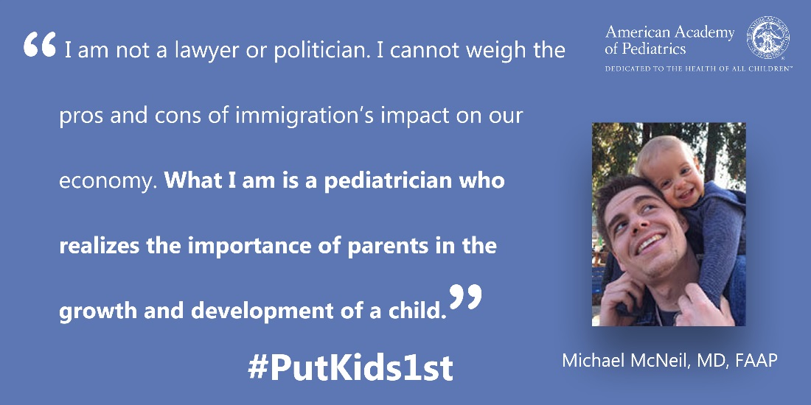

Template Letter-to-the-Editor and Op-Ed Messages on Protecting Immigrant Children
Please consider writing an op-ed to your local newspaper explaining why it is important to protect immigrant children and families. Op-eds are an effective medium to communicate your opinion about a timely issue in a local or national media outlet. Op-eds are typically 500-600 words in length, though it is always important to check with the individual publication for specific length requirements (most have guidelines listed on their websites).
Here are several example pediatrician op-eds/blogs that have been written on the topic: The Huffington Post, Philly.com and AAP Voices.
Important note: Rather than copy and pasting from this document, please view the messages below only as example framing, as AAP strongly recommends you tailor the language to make it your own and add personal stories or perspectives, using your experiences caring for immigrant children and families. Please generalize names and details to protect patient privacy and identity.
- As a pediatrician in {insert city, state}, I care for the health and well-being of all children—no matter where they or their parents were born.
- Immigrant families are our neighbors, they are part of every community, and they are our patients.
- The Executive Orders signed by President Donald Trump are harmful to immigrant and refugee children and families throughout our country.
- {Insert relevant personal anecdote or patient story of an immigrant child or family you care for}
- Children do not immigrate, they flee. They do not choose whether or how to travel to the United States. They are coming to our country seeking safe haven and they need our compassion and assistance.
- Far too many children in this country, many of whom are legal U.S. citizens, live in constant fear that they or their parents will be taken into custody or deported. When children are scared, it can impact their health and development.
- {Insert relevant examples of how children’s health and development can be impacted}
- Many of the children who will be most affected by these Executive Orders are the victims of unspeakable violence and have been exposed to trauma. These children are vulnerable, scared and deserving of our compassion.
- As a pediatrician, I care for all children. I urge our federal leaders not to view immigrant children as threats to our society, but rather the foundation of our country’s future.
Submitting your op-ed
Once you have initiated a draft op-ed, please contact Devin Miller (dmiller@aap.org) or Jamie Poslosky (jposlosky@aap.org) in the AAP Washington Office who can provide any suggestions or feedback, answer any additional questions or provide assistance with pitching.
Please note that many op-eds are considered “exclusive;” you can only submit your piece to one newspaper at a time. Should one publication decline to publish your piece, you can resubmit to another, but you should avoid sending your op-ed to several newspapers at once.

Key Recommendations from AAP Policy on Family Detention

According to U.S. Customs and Border Patrol, in fiscal year 2016, a total of 59,692 unaccompanied children were detained as they crossed into the United States over the southern border. The length of detention varies, but children can be detained in processing centers for several days at a minimum. Below are key recommendations from the AAP’s April 2017 policy statement, “Detention of Immigrant Children” and news release. Feel free to draw from these in your own messaging.
Children deserve our compassion and assistance.
- Children do not immigrate, they flee. They are seeking safe haven in our country and they need our help and support.
- Many of the children approaching our southern border have been victims of unspeakable violence and have been exposed to trauma. They are fleeing countries with the highest rates of violence in the hemisphere, overlaid with high rates of poverty. These children are vulnerable, scared and deserving of our compassion. Most of all, they deserve to be healthy and safe.
- All immigrant children and families seeking safe haven in the U.S. should be treated with dignity and respect. In every decision about children, government decision-makers should prioritize the best interests of the child.
- AAP urges the Administration to ensure that children and families who are fleeing violence and adversity can continue to seek refuge in our country.
- Broad scale expansion of family detention only exacerbates their suffering.
Children should never be separated from their parents or caregiver.
- When families are separated, it causes harm to children.
- Separation from caregivers can cause toxic stress in children. When children are scared, it can impact their health and development. As children develop, their brains change in response to environments and experiences. Fear and stress, particularly prolonged exposure to serious stress – known as toxic stress – can harm the developing brain and harm short- and long-term health.
  - In the short term, this can manifest in problems with toileting, sleeping, eating learning and concentrating, as well as symptoms of depression, anxiety and post- traumatic stress.
  - In the long term, we know that children who are exposed to serious early stress are more susceptible to heart disease, diabetes, and depression.
  - We also know that enduring, supportive relationships with caregivers can help children to overcome stress and build healthy brains. The buffering support of loving parents is important to children in situations of ongoing stress
- Currently, families may be separated in detention, especially if children are traveling with their father or in the care of another male relative. Only one (Berks) family detention center accepts men, and the processing centers where families arrive first are all segregated by gender.
- If asked how many children have been separated from their parents/family during detention:
  - This type of data has not been made available. However, we know from reports of observers who have visited and interviewed refugees in detention, that separation of children from their parents has been frequent, and traumatic.
- Share personal anecdotes of children who have been separated.
  - Pediatricians who have visited families in detention describe situations in which children are too fearful to leave their mother's side to play outside on playground equipment. After seeing their father taken to a separate facility, they are anxious their mother will disappear, too.
  - One father, who was with his son, was asked where the mother of his son was. He cried and said "I have no idea, they separated my daughter and put her with my wife and I don't know where."
  - One father said his 12-year-old daughter was separated from him and her brothers, and couldn't see any of them. She spent three days in the processing center, crying.
- Many of these families have fled violence, assembled belongings with little notice and undergone danger in transport across the border. Separating children from their caregivers at the time they most need their parent's support is cruel and devastating.
- Supportive, caring relationships with parents and caregivers can help children overcome stress and buffer the impact of traumatic events. Traveling across the border and being detained are often traumatic for children. Maintaining contact with caregivers, especially as they confront new and unfamiliar experiences, is critical for these children.
Children should never be placed in detention centers.
- No child should be in detention. Most of these families are not a risk to society and they should be released as a family to the community, not held in detention.
- There is no evidence that any amount of time in detention is "safe" for children. In fact, even short periods of detention can cause psychological trauma and long-term mental health risks for children.
- Studies show that children show signs of physical and emotional stress when they are detained. These can include developmental delay, poor psychological adjustment, anxiety, depression, suicidal ideation, and other behavioral problems.
- Conditions within existing processing centers, like McAllen, are egregious and not acceptable for children. Children in these centers do not have adequate bedding, food or water. They may sleep on a cement floor. Temperatures are very cold and lights are on 24 hours a day.
  - Share personal anecdotes of visits to detention centers.
- Post-traumatic stress symptoms can last long after children are released, negatively impacting their emotional, mental and physical health into adulthood.
  - Share personal anecdotes of children you have cared for after detention.
- What we know as pediatricians is that children fare best in community settings, under the direct care of parents or others who love them.
- Instead of detention, AAP recommends releasing children and their families into the community while their immigration cases proceed. This would end both detention and the placement of ankle tracking devices on parents. Families should not be separated; this includes older siblings, parents and other family members.
  - Currently, more than 75 percent of families held in family residential centers pass their "credible fear" or "reasonable fear" interviews – meaning they have a right to seek protection in the U.S.
All children in the U.S. should have access to health care, education, and other essential services.
- The mission of the American Academy of Pediatrics is to protect the health and well-being of all children—no matter where they or their parents were born.
- As pediatricians, our role is to help children be healthy while they are in our communities. The health of any community depends on the health of ALL members of that community.
- From the moment they are in the custody of the United States, children should have access to health care. Once released from custody, there are only a handful of states that provide Medicaid coverage regardless of legal status. This becomes a barrier to their care.
- Children should have access to legal representation in all immigration proceedings.
- All children in the U.S. have a right to free public education, regardless of immigration status.
- When they are released from detention, immigrant children coming across the southern U.S. border will resettle to communities across the country. Communities throughout the U.S. will have an opportunity to welcome them, and we want all children in our communities to be healthy.
- AAP recommends a "trauma-informed" approach to caring for children who have been in detention. Treatment methods proven to help children and adults who have experienced psychological trauma should be used in caring for children who have been detained.

Additional Resources to Guide Your Efforts
AAP Policy & Immigrant Child Health References: For you to draw from when you craft your messages.
- The Academy’s April 2017 policy statement, “Detention of Immigrant Children” and press release
- Resources for pediatricians caring for newly arrived immigrant children
- Immigrant child health toolkit to provide practical information and resources for pediatricians to address common matters related to immigrant child health
AAP News Articles & Releases: To get a sense of AAP’s messages and to share on social media.
- American Academy of Pediatrics Urges Compassion and Appropriate Care For Immigrant and Refugee Children
3/13/2017
- AAP News: AAP policy says no child should be in detention centers or separated from parents
3/13/2017
- AAP Statement on Revised Immigrant and Refugee Travel Ban Executive Order
3/6/2017
- AAP Statement Opposing Separation of Mothers and Children at the Border
3/4/2017
- Leading Pediatric Medical Organizations Respond to Recent Executive Orders Impacting Immigrants and Refugees
2/14/17
- AAP Statement on Protecting Immigrant Children
1/25/17
- AAP Voices: Children should be cared for, not caged
1/6/2017
- AAP News: ‘Brewing humanitarian crisis:’ AAP leaders, members visit Texas border to assess needs of immigrant children
1/6/17
AAP & Immigrant Child Health News Coverage: To share on social media and to draw inspiration for your own messaging
- The Albuquerque Journal: Immigration policies are bad for children’s health
5/25/2017
- The Guardian: Undocumented immigrants avoid vital nutrition services for fear of deportation
5/9/2017
- Medscape: What Deportation Centers Are Like for Kids: AAP Takes a Look
5/8/2017
- The Washington Post: DHS is considering separating mothers and children who cross the border illegally
3/4/2017
- Seattle Times: A 5-year-old with PTSD: the reality of deportation policies
2/24/2017
- Medscape: The Black Cloud of Deportation and Stress in Immigrant Children
2/8/2017
- Philly.com: Make no mistake, immigration order harms children
2/1/2017
- The Huffington Post: How President Trump’s Executive Action On Immigration Is Dangerous For Children
1/31/2017
- The Atlantic: The Toxic Health Effects of Deportation Threat
1/27/2017
- NBC News: Pediatricians Speak Out Against President Trump’s Immigration Orders
1/26/17
- Forbes: American Academy Of Pediatrics: Protect Immigrant Children After Trump Immigration Crackdown
1/26/2017

