Legislature Module in WebCMS

- Log in WebCMS: http://webcms.aap.org/
- Under the “Reports Module” select “Legislator Report”
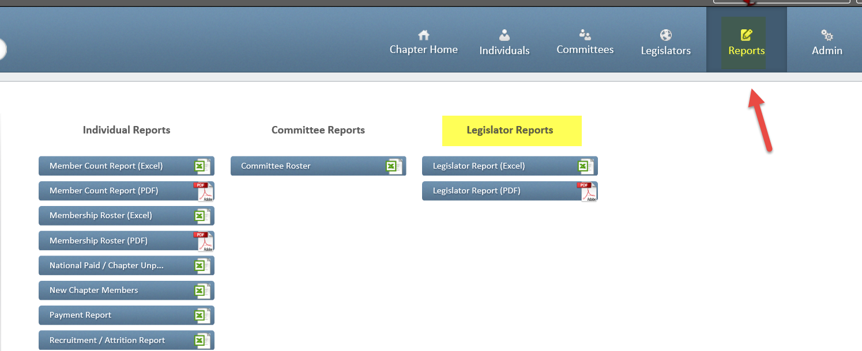
- Under “Legislator type”, select “Federal Senate” and “Federal House”. Run report.
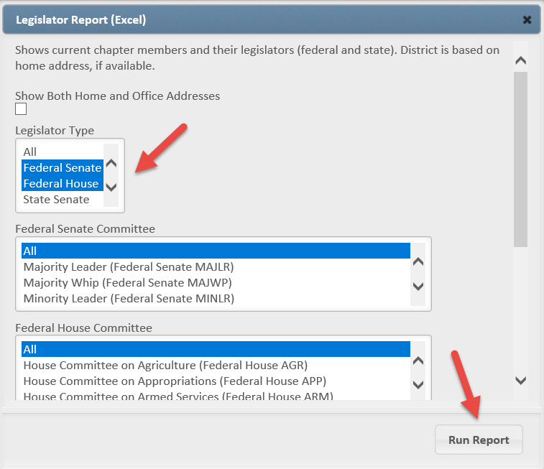
- In the Excel spreadsheet, scroll to the right hand side to view the Legislator details.
