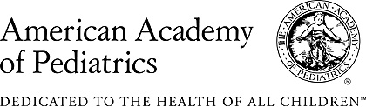

Protecting Children’s Coverage:
An Advocacy Toolkit for AAP Members, Leaders and Chapters
Spring and Summer 2017
Over the next two months, the Senate is preparing to debate and pass health care legislation. This is a critical time for advocacy, which is where you come in.
The following resources will help equip pediatricians to advocate to protect children’s health care coverage as the American Health Care Act (AHCA) is considered by the U.S. Senate. This document and all accompanying resources will be kept up-to-date and can be accessed on federaladvocacy.aap.org. Please bookmark this page and refer to it there as the landscape continues to evolve.
The next congressional recess is May 29 – June 2. This is an opportune time to reach your members of Congress while they are in their home districts.
The goal of this toolkit is to give you the ideas and messages necessary to engage with your members of Congress and to speak out in the media or on social media about the importance of health care coverage for your patients.
Tell us how it’s going! We are relying on you to give us your on-the-ground perspective about what you’re hearing from your legislators’ offices as you reach out. Please drop us a line and let us know what you’re up to and what you’re hearing by emailing kids1st@aap.org.
Also, please coordinate your advocacy activities with your AAP chapter leaders and executive director. We all need to stay in the boat!
Table of Contents
How the American Health Care Act Impacts Children: What You Need to Know
- Specific bill provisions that impact children
- AAP’s key messages on the AHCA
- Frequently Asked Questions
Opportunities to Take Action
- Week of May 29: Memorial Day recess
- Now until the August recess: share how the health care debate impacts you and your patients
Customizable Resources (included in toolkit)
- Template Email to Members of Congress: Protect Gains in Children’s Health Care Coverage
- Template Talking Points to Members of Congress: Protect Gains in Children’s Health Care Coverage
- Template Letter-to-the-Editor and Op-Ed Messages on Protecting Children’s Coverage
- Sample social media messages and graphics: #Docs4Coverage and #KeepKidsCovered
- AAP’s AHCA advocacy summary (can be used for chapter newsletters)
Resources to Reference (external links): Use these to draw messages and local data when engaging with Congress, speaking up in the media or sharing messages on social media.

How the American Health Care Act Impacts Children: What You Need to Know
Legislative process: How We Got Here
On May 4, the U.S. House of Representatives passed the American Health Care Act (AHCA) by a vote of 217-213. The bill is now being considered by the U.S. Senate, where a group of 13 Republican senators are working on initial changes to the bill that could garner the 50 votes needed to pass.
The Senate’s group of 13 members are currently meeting to amend the House bill, in addition to other, small groups of Republican senators who are also drafting alternatives to the House’s legislation. Soon, Congress will be going on Memorial Day Recess and members will be returning to their home states May 29 – June 2.
Should the Senate pass its own version of the American Health Care Act, it would need to be conferenced with the House bill and the same exact bill would need to be passed by both chambers to then be sent to President Trump for signature into law.
Senate Majority Leader Mitch McConnell said he plans to introduce a bill before the July 4th recess, so the next two months will be crucial.
Background: What’s in the Bill That Impacts Children
What provisions in the AHCA impact children?
- Changes Medicaid from an entitlement program into a capped funding program, in addition to other smaller policy changes that would also hurt children. Medicaid is a state-federal partnership; each state has flexibility to design its program within federal guidelines and receives federal matching funds. For children, Medicaid is a primary source of coverage and provides guaranteed coverage, pediatrician-recommended services and cost-sharing protections.
  - Under a capped funding model, the federal government would limit the dollars given to states to cover the whole Medicaid-eligible population, regardless of their health needs. Once the allocated funds are exhausted, states would have to fund the gap with state dollars to continue providing services. That likely means states would look to lower physician payments, tighten eligibility standards, and eliminate certain benefits to make up any funding shortfalls.
  - The bill gives states the option to receive federal funding through a per capita cap or a block grant for children and non-disabled adults. Under the block grant option, states would not be required to provide the comprehensive set of benefits to children that are currently required. Both models would have the same damaging effects – lower physician payments, tighter eligibility standards, and more limited benefit packages.
  - States that want to keep their own spending under the cap will have choices to make about how to use limited resources—all of them bad for beneficiaries and providers. Capped funding is also inflexible and does not adjust for factors like a public health crisis such as Zika, which could increase demand on the health care system, or account for economic recessions, which saw significant increases in Medicaid enrollment in 2008-2009.
- Eliminates the Medicaid expansion. Currently, as part of the Affordable Care Act, states have the option of expanding their Medicaid programs to cover parents and other individuals up to 138% of the federal poverty limit (about $16,000/year for an individual or $28,000/year for a family of three). The federal government currently pays for expansion at 95%, with states only responsible for 5%, and then the federal government pays 90% starting in 2020, with that ratio locked in place in perpetuity. This bill phases out expansion altogether in 2020.
- Allows insurers to return to the practice of discriminating against those with pre-existing conditions, effectively denying coverage by charging them unaffordable premiums.
  - While it is true that the AHCA preserves the ACA pre-existing condition exclusion, meaning those applying for coverage can’t be denied because of a preexisting condition, other changes would allow such coverage to be completely unaffordable and meaningless.
  - The AHCA would allow states to waive community rating, meaning that coverage for those with pre-existing conditions could be radically more expensive than it would be for those who are healthy. The way the bill is written, insurers would be allowed to charge much higher premiums to those who are sick in states that request the aforementioned waivers.
  - The bill proposes creating high risk pools, which would sell plans to those who have complex or chronic health conditions and are priced out of the market, however experts have raised concerns that the funding provided in the bill for the high-risk pools is not nearly enough to cover costs.
- Allows states to eliminate the required coverage of essential health benefits, which in turn would effectively eliminate the Affordable Care Act’s limit on out-of-pocket costs and ban on lifetime limits.
  - That means that for those who live in states that opt to scale back essential health benefits, enrollees could see out-of-pocket costs increase when they were previously capped, and they could also see their plans re-instate limits on how much medical care a person can accrue in a lifetime.
  - Before the ACA, plans frequently excluded coverage for services like maternity care, mental health treatment, or prescription drugs. That means that even if people with pre-existing conditions could afford their premiums, their health insurance might exclude the treatment they need.
  - Before the ACA, 105 million people, most with coverage through their employers, had plans with lifetime limits on benefits, meaning their insurance coverage could end exactly when they needed it most. Eliminating the ACA’s standards for the services that plans must cover in effect waives its bans on annual and lifetime limits as well.
AAP’s Key Messages
The following are key messages the AAP has used in its opposition to the AHCA. Please feel free to use these messages to guide and inform your advocacy, including the customizable resources below.
- The rate of children's health coverage in our country is at a historic high of 95 percent; the American Health Care Act would not only halt this progress, it would tear it down.
- The AHCA fundamentally changes the way the Medicaid program has functioned for the last 52 years. Those who will suffer the most are those who need health care the most, including the 37 million children who rely on Medicaid.
- Though Medicaid is an entitlement program, it is also an empowerment program.
  - Medicaid allows families to hold down jobs while caring for ill children. It allows pregnant women to access vital services to ensure she and her baby stay healthy, and it provides critical supports for people with disabilities so they can live independently.
- The AHCA also allows insurance companies to once again go back to denying affordable coverage to those with pre-existing conditions.
  - The bill allows insurers to go back to putting annual and lifetime limits on coverage, meaning that a premature baby on private insurance could exceed her lifetime limit on coverage before she even leaves the hospital.
- The AHCA eliminates the Medicaid expansion, a vital safety net that has allowed many parents and other family members to access affordable coverage for the first time.
  - Healthy parents, healthy children. Research shows that when parents have health care coverage, they are more likely to go to the doctor, miss less work, and are better able to care for their children.
  - For example, Medicaid covers maternal depression screening and treatment, which has a direct impact on the health of the mother’s infant.
  - Children are also more likely to be insured when their parents are insured.
- The American Health Care Act is bad policy for children and dangerous policy for our country.
  - Children are not little adults. They need pediatric-specific health care services. Current law requires that health plans cover “pediatric services, including oral and vision care.” The AHCA would allow states to eliminate these essential health benefits.
  - The law also requires that children receive other important “essential health benefits” including mental health care, newborn care, emergency care, and prescription drugs. Children with disabilities and other special health care needs receive habilitative care and chronic disease management. These protections for children would also be jeopardized by the AHCA.
  - The AHCA would drastically alter Medicaid, jeopardizing children's health. Capping federal funding will lead to lower physician payments, tighter eligibility standards, and more limited benefit packages. Limited Medicaid funding would directly threaten the comprehensive pediatric benefit known as Early and Periodic Screening Diagnostic and Treatment (EPSDT), which ensures children — especially those with complex health care conditions and special health care needs — get regular check-ups and treatment.
  - The AHCA would make coverage less affordable. The bill reduces tax credits and eliminates subsidies to help families afford insurance that meets their needs.
Frequently Asked Questions
If children lose their Medicaid coverage, won’t they be covered through the Children’s Health Insurance Program (CHIP)?
No. CHIP and Medicaid work in partnership; CHIP builds on the foundation of Medicaid to cover children in working families whose parents earn too much to qualify for Medicaid but who earn too little to afford private insurance. Medicaid covers children, parents and individuals who are low-income and/or who have complex health conditions. Through Medicaid, children are guaranteed benefits that cover a comprehensive array of medically necessary services, including developmental, vision and hearing screenings. These benefits are viewed by pediatricians as the gold standard of preventive care for children.
The American Health Care Act would put these benefits in extreme peril. It would fundamentally disrupt Medicaid as we know it.
The bill changes Medicaid from the flexible federal-state partnership it is today into a capped funding system that does not evolve with the needs of the population. One of the most dangerous falsehoods being promoted by champions of this bill is that children will not be harmed if it passes. Make no mistake – as one of the leading sources of coverage for children across the country and in our state, capping Medicaid funding in any way will harm children.
Funding for the CHIP program expires on September 30th, and the AAP is urging Congress to fund a clean, 5-year extension of CHIP funding without delay, so states can plan their budgets and families can be assured of their children’s coverage. This effort to renew CHIP is an important, but separate effort from the AHCA’s changes to Medicaid.
How would AHCA, if passed in its current form, impact patients on Medicaid?
Under this bill, states would have less federal funding so if they face funding shortfalls in the future they could tighten eligibility standards, possibly leading children and their families to lose coverage, or lose some of the comprehensive benefits like screenings that are currently included. It will vary state by state, which will make it even more confusing and uncertain for families.
Beginning in 2020, the federal funding for Medicaid expansion to adults would go away.
States would have the option of converting Medicaid to a block grant for children, adults (other than seniors and people with disabilities), or both. States taking this option would no longer have to cover the comprehensive pediatric benefit that federal law now requires known as EPSDT (Early and Periodic, Screening, Diagnostic and Treatment), which ensures children — especially those with complex health care conditions and special health care needs — get regular check-ups and treatment. States could also charge unlimited premiums, deductibles, and copayments and likely impose waiting lists or caps on the number of children or adults who could enroll.
To compensate for these cuts, states would have to raise taxes, cut other budget areas like education, or as is far likelier, cut Medicaid spending. Since Medicaid is highly efficient, with per-beneficiary costs that are lower than (and growing more slowly than) private insurance, states would likely have to make cuts like restricting eligibility, reducing services, cutting payments to providers, or a combination of all three approaches to rationing care. Any of these options would hurt children on Medicaid.
The bill also allows states to impose a work requirement on non-disabled adults as a condition of Medicaid coverage. However, most Medicaid expansion adults who are capable of working are currently employed. Many of these families are already struggling to care for a child with special health care needs, or working to afford food and insurance. Not knowing whether they will be able to depend on Medicaid for care would just add one more barrier for them to overcome, and a work requirement undercuts Medicaid as a lifeline for those who most need it.
What does the Academy want the Senate to do as they consider the bill or other health care reform changes?
The American Academy of Pediatrics is urging the Senate to keep Medicaid intact in any bill they propose. That means keeping it as an entitlement program, keeping its benefits like EPSDT intact, and keeping Medicaid expansion a viable option for states. We are urging the Senate to preserve the consumer protections so many children benefit from in public and private coverage, like guaranteeing affordable and comprehensive coverage for children with pre-existing conditions, and banning caps on lifetime and annual coverage so insurance remains meaningful and robust for those who need it most.
What does the Congressional Budget Office “score” of the AHCA really mean?
On May 24th, the Congressional Budget Office (CBO) confirmed that the AHCA will result in fewer people insured, market instability, and higher out-of-pocket costs for millions of Americans. The nonpartisan analysis from the CBO estimates that the AHCA would cause 23 million more Americans to lose health care coverage by 2026. The CBO score also reconfirms the AHCA’s devastating effects on the Medicaid program. Federal Medicaid spending would be cut by $834 billion or 16.7 percent over the next ten years, and the program would cover 14 million fewer people.
This new analysis of the latest version of the House-passed bill confirms the catastrophic impact that the AHCA would have on children. Next year alone, 14 million more Americans would be uninsured. The newest changes would allow states to waive key consumer protections, paving the way for fewer benefits, higher out-of-pocket costs, and potentially millions of consumers with pre-existing conditions becoming uninsured. The CBO assumes that states with about half of the nation’s population will take up waivers allowed under the House bill to eliminate or weaken ACA protections for people with pre-existing conditions, and those with pre-existing conditions would face prohibitively expensive premiums. The CBO also confirms that the money allocated for high-risk pools is insufficient to cover those with the greatest needs.

We Need Your Voice: How to Take Action
There are several upcoming opportunities to take action in support of protecting children’s coverage.
Congressional Recess: May 29-June 2
During this week, members of Congress will be in their hometowns and states meeting with constituents. Take the opportunity to attend a town hall or request to meet with your federal legislators in person to urge them to protect children’s coverage.
If you want to reach out proactively to offer yourself as a resource for any public event in support of children’s health care, or to offer a tour of your clinic or institution to your federal official, now is the time to do so.
Senate advocacy vs. House advocacy
Here is the directory for U.S. Senators and here is the directory for U.S. Representatives.
For your U.S. senators: Urge your U.S. senators to oppose the AHCA in their chamber and press for better policies that prioritize children's health and protect Medicaid.
For your U.S. representative: If your representative voted yes on this bill, they should continue to hear from you about why you oppose that decision. This Washington Post article recaps how members of the House voted on the bill. If your representative voted no, encourage them to continue pressing for better policies that prioritize children's health and protect Medicaid.
Ongoing: Share your Patient Stories
If you have a patient impact story about Medicaid or access to health care coverage generally that would be adversely affected by the efforts currently developing in Congress, please share the following information with kids1st@aap.org with “Health Care Coverage Patient Story” in the subject line. In the body of the message, please include:
- Your name, title, and role within AAP
- Your institution, city and state
- A brief summary of an experience you had with a family, including:
  - No personal medical information that would violate HIPPA (feel free to change personal details in order to comply)
  - Vivid details about the patient’s condition/family’s experience, including any humanizing details about your interactions/observations
  - A specific reference to the federal policy protection or barrier (access to care within Medicaid, etc.)
  - An ask of how to protect that benefit or address that barrier

Template Email to Senators: Protect Children’s Coverage

Visit federaladvocacy.aap.org for the latest background information, emails and talking points on this issue.
Dear Sen. SENATOR NAME SEE CONGRESSIONAL DIRECTORY:
As a pediatrician, a constituent and a member of the American Academy of Pediatrics [CHAPTER/COMMITTEE/COUNCIL/SECTION NAME], I urge you to preserve the gains made in children's health care coverage and ensure this coverage is comprehensive, affordable and accessible for children and families.
Today, the number of children with health insurance in [STATE NAME] is at an historic high of [DATA FROM STATE FACT SHEET] percent. This progress was made possible by Medicaid, the Children's Health Insurance Program, and the Affordable Care Act working together.
Proposals to cap and cut Medicaid are detrimental to children and families across the country. I am deeply concerned with any proposal that would cut federal funding for Medicaid. Such a federal cut would shift costs to states and likely lead to enrollment cuts, meaning less coverage for those who need it most: children with special health care needs and those from low-income families.
Children are not just little adults; they have unique health needs, and access to affordable, high-quality health coverage is essential to keeping children of all ages healthy. Through Medicaid, children are guaranteed benefits that cover a comprehensive array of child-specific medically necessary services, including developmental, vision and hearing screenings.
In addition, the bill allows insurers in states that seek waivers to return to the practice of discriminating against those with pre-existing conditions, effectively denying coverage by charging them unaffordable premiums, which would leave millions of people who need care unable to get it.
Please keep the needs of America's children at the forefront as you consider changes to our health care system. I urge you to reconsider moving forward with proposals that will move health coverage for children backward. Please oppose any policy that would fundamentally alter Medicaid and leave children worse off.
Thank you for all you do for children in our state and across the country.

Template Talking Points: Protect Children’s Coverage
Please use the talking points below to call your U.S. senator and urge him or her to preserve gains in children’s health care. Feel free to incorporate data from your state:
- As a pediatrician and a member of the American Academy of Pediatrics, I am calling to preserve the gains made in children's health care coverage and ensure this coverage is comprehensive, affordable and accessible for children and families as you make health care policy decisions.
- The coverage rate among children in the United States is at a historic high: 95 percent. This progress was made possible by Medicaid, the Children's Health Insurance Program and the Affordable Care Act working together.
- I am deeply concerned with any proposal that would cut federal funding for Medicaid, which would shift costs to states and likely lead to enrollment cuts, meaning less coverage for those who need it most, children with special health care needs and those from low-income families.
- Children are not just little adults; they have unique health needs, and access to affordable, high-quality health coverage is essential to keeping children of all ages healthy. Through Medicaid, children are guaranteed benefits that cover a comprehensive array of medically necessary services, including developmental, vision and hearing screenings.
- In addition, I oppose any bill that allows insurers in states that seek waivers to return to the practice of discriminating against those with pre-existing conditions, effectively denying coverage by charging them unaffordable premiums. This would leave millions of people who need care unable to get it.
- Please keep the needs of America's children at the forefront as you consider changes to our health care system. I urge you to reconsider moving forward with proposals that will move health coverage for children backward.
- Thank you for all you do for children in our state and across the country.

Sample social media messages and graphics: #Docs4Coverage and #KeepKidsCovered

Consider sharing messages on social media on a regular basis linking to your state fact sheet or any other AAP resource or letter related to protecting children’s coverage. Below are some sample messages to consider using and ways to look up your members of Congress on Twitter to mention them specifically. The two main hashtags AAP is using for this effort are #KeepKidsCovered and #Docs4Coverage, which many other leading primary care groups are using as well.
Handles for House of Representatives: https://twitter.com/cspan/lists/u-s-representatives/members and Senators: https://twitter.com/cspan/lists/senators/members
AAP Handles to follow: @AmerAcadPeds, @AAPPres, @DrRemleyAAP, @AAPNews, @HealthyChildren
AAP Chapters: https://twitter.com/AmerAcadPeds/lists/aap-chapters/members
Sample messages:
- RT to tell @ElectedOfficialTwitterHandle that consistent, affordable coverage gives {Your State Abbreviation} kids a better chance for a healthy future. #Docs4Coverage
- .@ElectedOfficialTwitterHandle I’m a pediatrician & constituent with one message: #KeepKidsCovered.
- Children’s health coverage in Your State is at x%. Let’s protect the gains we’ve made & #KeepKidsCovered!
- I’m with #Docs4Coverage and @AmerAcadPeds to ask Congress to #KeepKidsCovered!
- Medicaid matters for children. .@ElectedOfficialTwitterHandle please #KeepKidsCovered! (insert graphic or state fact sheet)
Sample graphics (right-click to “Save Image As” and use these files on Twitter and Facebook as images)
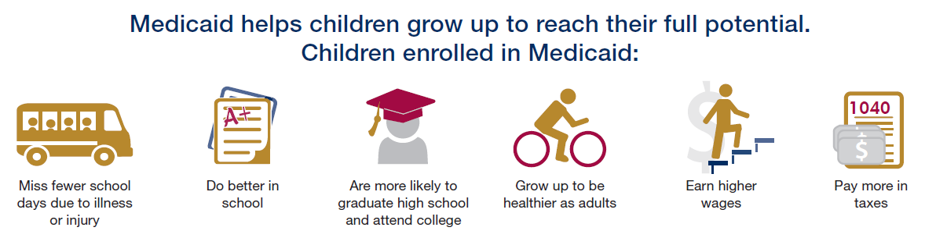
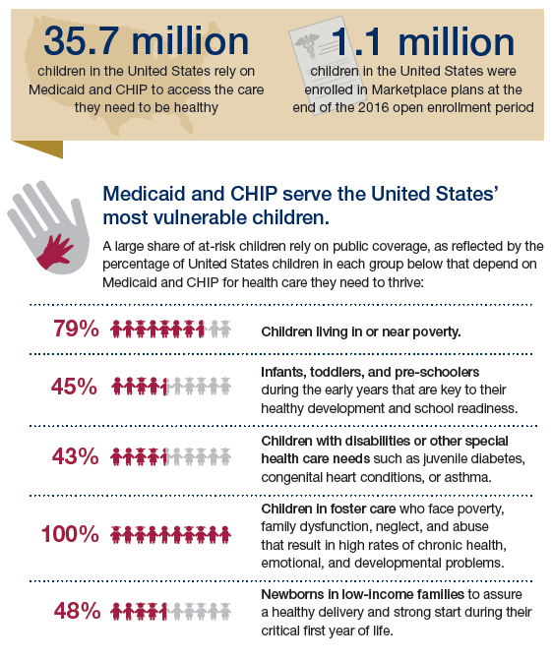
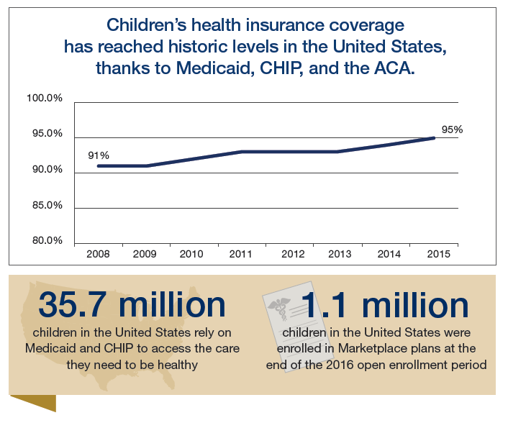

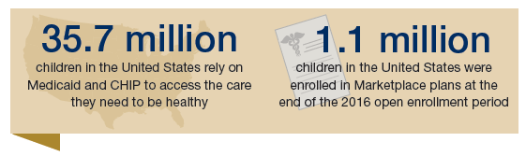
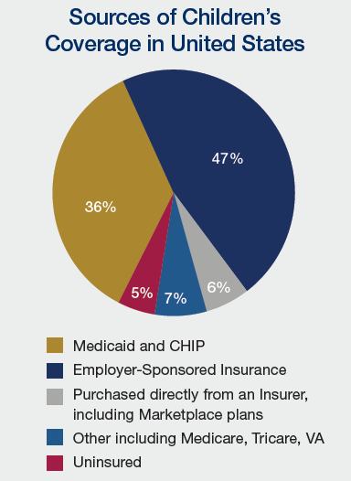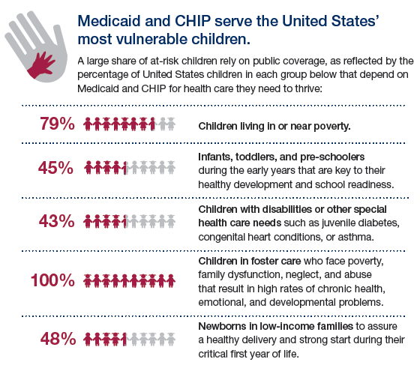

Template Letter-to-the-Editor and Op-Ed Messages on Protecting Children’s Coverage
Please consider writing an op-ed to your local newspaper explaining why it is important to preserve the gains made in children’s health care coverage. Op-eds are an effective medium to communicate your opinion about a timely issue in a local or national media outlet. Op-eds are typically 500-600 words in length, though it is always important to check with the individual publication for specific length requirements (most have guidelines listed on their websites).
Important note: Rather than copy and pasting from this document, please view the messages below only as example framing, as AAP strongly recommends you tailor the language to make it your own and add personal stories or perspectives on why access to affordable, comprehensive health care coverage is so critical.
Ideas for personalization:
- Do you have a patient story or personal anecdote that highlights children’s unique health needs and provides an example of why health care must be accessible, comprehensive and affordable?
- Do you have a high number of Medicaid enrollees in your patient population? Explain why Medicaid matters to these families.
- Explain the importance of preventive care in pediatrics, emphasizing why the benefits guaranteed in Medicaid are so critical to lifelong health and development.
- If you live in a state that expanded Medicaid under the ACA, explain why it is important that these children and families can keep their coverage.
- Emphasize why it is important for children with pre-existing conditions to be able to access comprehensive and affordable health care insurance and how annual and lifetime limits on coverage can be financially devastating for families. Insert a patient anecdote as relevant.
State-specific resources: We encourage you to personalize your op-ed with state-specific statistics and data. These state-by-state fact sheets include timely and relevant information that you should feel free to weave into your piece.
Key messages:
Below are key messages to help guide your op-ed draft. Additional messages to help guide your piece can be found here:
- As a pediatrician in {insert city, state}, I know first-hand the importance of ensuring children have access to affordable, comprehensive health care coverage, and I stand with the American Academy of Pediatrics in urging our senators (insert senators’ names) to protect children’s coverage.
- Right now, the coverage rate among children in the United States is at a historic high: 95 percent. {In our state/name of representative’s district}, that number is {insert state/district data} This progress was made possible by Medicaid, the Children's Health Insurance Program and the Affordable Care Act working together.
- Any bill that would make drastic changes to Medicaid, which has served as a lifeline for children in our state and across the country, would reverse this progress and jeopardize children’s health.
- Any proposals that would lead to cuts to eligibility in the Medicaid program would mean less coverage for those who need it most, children with special health care needs and low-income families.
- {Insert state specific data on how many children are in Medicaid in your state}
- Through Medicaid, these children are guaranteed benefits that cover a wide array of services like developmental, vision and hearing screenings.
- {Insert personal anecdotes or patient stories about how Medicaid works for children in your state}
- Any bill that allows insurers in states that seek waivers to return to the practice of discriminating against those with pre-existing conditions, effectively denying coverage by charging them unaffordable premiums, would leave millions of people who need care unable to get it.
- {Insert personal anecdote or patient story as relevant}
- Children with health insurance are more likely to go to the doctor to get the care they need when they need it. They are also more likely to attend school, graduate from high school, go to college, pay more in taxes, and become healthy, successful adults than their uninsured peers.
- I urge our federal leaders to keep the needs of America's children at the forefront as they consider changes to our health care system.
- Our children and their families deserve the peace of mind knowing they have access to reliable health coverage that works.

Submitting your op-ed
Once you have initiated a draft op-ed, please contact Devin Miller (dmiller@aap.org) or Jamie Poslosky (jposlosky@aap.org) in the AAP Washington Office who can provide any suggestions or feedback, answer any additional questions or provide assistance with pitching.
Please note that many op-eds are considered “exclusive;” you can only submit your piece to one newspaper at a time. Should one publication decline to publish your piece, you can resubmit to another, but you should avoid sending your op-ed to several newspapers at once.

AAP’s AHCA Advocacy Summary
The following section summarizes the Academy’s advocacy to oppose the American Health Care Act. Please feel free to use this language as a guide for newsletters/updates shared with AAP chapters or committees, councils and sections.
On May 4, the U.S. House of Representatives passed the American Health Care Act (AHCA) by a vote of 217-213. The bill is now being considered by the U.S. Senate, where a group of 13 members are currently meeting to amend the House bill, in addition to other, small groups of Republican senators also drafting alternatives to the House’s legislation. The bill’s passage in early May came after the legislation was previously pulled from House consideration in late March when it did not have enough votes to pass the chamber.
The Academy has strongly opposed the legislation since its introduction, citing the drastic changes it makes to Medicaid that would be detrimental to children and families as well as its provisions that make health care coverage less comprehensive and affordable for those who need it the most. AAP has joined with other leading medical organizations and children’s health groups to amplify these concerns, and has been a relied upon source by the media to share the impact of the AHCA on children and families. At every point in the legislative process, the Academy has been weighing in as the voice for children.
Immediately following the bill's passage, the Academy issued its own statement along with a statement joining the American Academy of Family Physicians, American College of Physicians, American Congress of Obstetricians and Gynecologists, American Osteopathic Association and the American Psychiatric Association.
Leading up to the House passage, pediatricians were speaking out, urging their U.S. representatives to vote "no" through calls, emails, tweets and the media, including numerous op-eds and letters-to-the-editor published in local and national newspapers across the country.
"Your advocacy efforts played a pivotal role in blocking previous versions of AHCA and in making this vote a difficult one for the House," said AAP President Fernando Stein, MD, FAAP, in a message sent to all AAP members. "It also gave us the momentum we need now to continue the fight."
In its current form, the AHCA would:
- Change Medicaid from an entitlement program into a capped funding program;
- Eliminate Medicaid expansion;
- Allow insurers in states that seek waivers to return to the practice of discriminating against those with pre-existing conditions, effectively denying coverage by charging them unaffordable premiums.
- Allow states to waive requirements to cover essential health benefits, which in turn eliminates the protections for annual and lifetime caps on coverage
The AHCA would cut over $800 billion from the Medicaid program over the next decade, transforming Medicaid from an entitlement to a capped funding stream or block grant, shifting costs to states and likely leading to enrollment and/or benefit cuts. Currently, 37 million children rely on Medicaid for health care coverage. Through the program, these children receive Early and Periodic Screening, Diagnostic and Treatment (EPSDT) benefits, which are the definitive standard of pediatric care.
In fact, children make up the single largest group of people who rely on Medicaid, including those with special health care needs and those from low-income families. The AHCA would jeopardize care for these vulnerable children.
On May 24th, the Congressional Budget Office (CBO) confirmed that the AHCA will result in fewer people insured, market instability, and higher out-of-pocket costs for millions of Americans. The nonpartisan analysis from the CBO estimates that the AHCA would cause 23 million more Americans to lose health care coverage by 2026. The CBO score also reconfirms the AHCA’s devastating effects on the Medicaid program. Federal Medicaid spending would be cut by $834 billion or 16.7 percent over the next ten years, and the program would cover 14 million fewer people.
This new analysis of the latest version of the House-passed bill confirms the catastrophic impact that the AHCA would have on children. Next year alone, 14 million more Americans would be uninsured. The newest changes would allow states to waive key consumer protections, paving the way for fewer benefits, higher out-of-pocket costs, and potentially millions of consumers with pre-existing conditions becoming uninsured. The CBO assumes that states with about half of the nation’s population will take up waivers allowed under the House bill to eliminate or weaken ACA protections for people with pre-existing conditions.
In addition, by allowing insurance companies to once again go back to denying affordable coverage to those with pre-existing conditions in states that seek waivers, conditions ranging from asthma to pregnancy to cystic fibrosis could devastate a family financially and leave those who need care unable to access it. Also, annual and lifetime caps on coverage could mean that a premature baby could exceed her lifetime limit on coverage before she even leaves the hospital. It is important to note that these provisions regarding pre-existing conditions and annual and lifetime caps also apply to private insurance plans (including employer-sponsored plans).
To the Academy, the AHCA is bad policy for children and dangerous policy for our country. The rate of children's health coverage in the United States is at a historic high of 95 percent; the AHCA would reverse this progress.
Looking ahead, should the Senate pass its own version of the American Health Care Act, it would need to be conferenced with the House and the same exact bill would need to be passed by both chambers to then be sent to President Trump for signature into law. In addition, the version of the bill the Senate passes must be budget neutral, meaning any amendments must save federal dollars.
As the Senate considers the bill and other health care reform changes, the Academy will continue to urge lawmakers on both sides of the aisle to forge a new path forward to protect children’s health care coverage. Pediatricians call on senators to press for better policies that prioritize children's health and protect Medicaid.

External Resources
Pediatricians are credible voices to speak out against the AHCA, or similar proposals, and their impact on children. Please consider lending your voice to speak up about the needs of your patients in social media or in local or national media outlets. The following resources can be useful for background and framing.
Press statements
- AAP press statements leading up to the House passage of the AHCA, opposing the bill:
  - (May 4): AAP Statement Opposing House Passage of American Health Care Act
  - (May 4): America's Frontline Physicians Urge U.S. Senate to Find a New Way Forward with Health Care
  - (May 1): AAP Statement Opposing Revised American Health Care Act
  - (March 24): America's Front Line Physicians Urge Congress to Find a New Way Forward to Protect Patients' Access to Care
  - (March 24): AAP Urges Congress to Forge New Path to Protect Children's Health Care
  - (March 22): Leading Children's Health Groups to House of Representatives: Keep Medicaid Strong
  - (March 8): America’s Front Line Physicians Express Serious Concerns with the American Health Care Act

Data & Tools
- State fact sheets summarizing children’s coverage with state-specific data

- State-by-state data on the AHCA’s financial impact on children.

- New infographic from the Kaiser Family Foundation: Medicaid’s role for children with special health care needs

- Breakdown of data by Congressional district and by age of children enrolled in Medicaid/CHIP, as well as a map showing the numbers of children on Medicaid/CHIP by state. You can filter just the state/district you need to pull from for any advocacy materials.

- An interactive map from Georgetown University Center for Children and Families showing Medicaid/CHIP enrollment by congressional district

- Information for AAP Chapters on how to use the WebCMS tool to match chapter members with their Congressional delegations

- Leading medical organizations’ joint principles for coverage, benefits and consumer protections as the Senate considers the AHCA
Media Coverage
- Pediatrician op-eds and letters-to-the-editor published across the country opposing the AHCA

- An interview on NPR’s 1A show with Lanre Falusi, MD, FAAP, on the bill and its impact on children and families

- An op-ed in the Charleston Gazette-Mail on the importance of protecting children’s coverage and calling out the harms of AHCA’s Medicaid cuts to children in the state

- An article in USA Today outlining the impacts of the bill on child health

