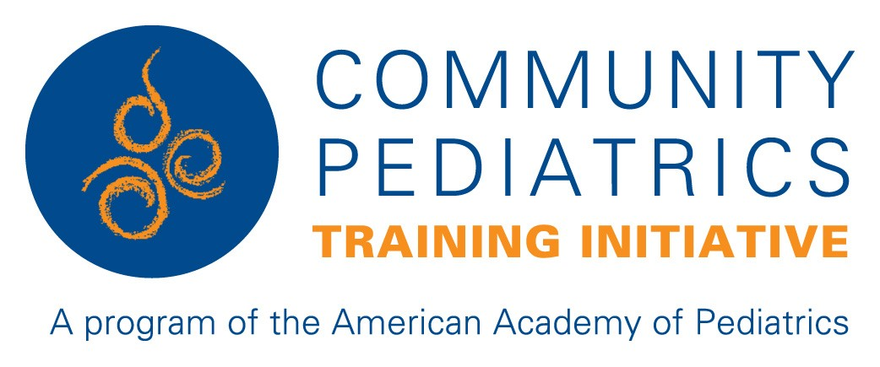

CPTI Advocacy Portfolio

1. Primary Area(s) of Concentration

Describe what unites your advocacy work. Include populations, issues, and communities of focus.

Enter text here

2. Personal Statement

Should include advocacy philosophy and create a narrative that explains your work in community health and advocacy. For example, you can describe your personal theory of being an effective advocate, illustrated by examples of your work. You may reflect on your strengths and experiences in advocacy, and show how your approach has evolved over time. It will be helpful to link your statement to effective change, or a vision of change.
This may be challenging to complete early in your career, so think of this as something to revisit and develop in the future.

Enter text here

3. Advocacy Engagement/Knowledge Dissemination

  - Advocacy Awards
  - Policy Testimony
  - Engagement with Media: Written
  - Engagement with Media: Audio/Video
  - Invited presentations/visiting professorships – impact, academic presentations

A. Advocacy Awards
Could be from Medical, State, Private, or Community Organizations

Year | Award | Sponsoring Organization | Level of Award  Departmental/Institutional/Regional/National/International

B. Policy Testimony
Do you have experience delivering testimony to policy-making bodies? This can be local, municipal, state or federal officials, agencies, commissions, boards etc. Testimony may be in-person, written, or in partnership with others. Make note if testimony was invited by policy makers.

Year | Policy Body Addressed | Topic and purpose/goals

C. Engagement with Media: Written
Do you have experience working with media? We will start with written/print media. This includes things like op-eds, letters to the editor, blog posts, etc. Also include significant leadership roles in social media engagement related to advocacy events on platforms such as Twitter, Facebook, or Instagram.

 | Written examples: Include op-eds, interviews, blog posts
Year | Topic | Media Outlet | Anticipated Audience  (who, #viewers, readers etc) | Link to text (if available).

D.Engagement with Media: Audio or Video
Tell us about your experience in working with voice or filmed media. This includes things like radio, TV, virtual platform (Zoom/Skype) interviews, and podcasts.
 | Video/Audio examples
Year | Topic | Media Outlet | Anticipated Audience  (who, #viewers, readers etc) | Link to audio/video (if available).

E. Invited presentations/visiting professorships
Regional/National/International Recognition of Advocacy Expertise
Include invited lectures, visiting professorships or other work that resulted from your content expertise related to your advocacy work.

Year | Nature of Recognition and Topic | Description of activities | Outcomes

4. Community Engagement/Outreach

Engagement with Communities/Community Based Organizations/Coalition/Collective Impact Organization/Serving on Boards
Have you worked with Communities or Community-Based Organizations (e.g. Non-profits, schools, camps, clubs, coalitions etc) to improve the health and well-being of kids and families in your community? Highlight activities where a significant relationship was formed with a community, or with existing organizations resulting in a longstanding relationship, significant commitment of time, and/or leadership role (e.g. serving on the board, founder, health advisor, or mentoring relationships). The expectation is to exclude one-time interactions/events or sports coaching, unless it had a focus on health and well-being of special populations or was related to broader advocacy missions. (e.g. Special Olympics)

Year | Time Commitment  (specify monthly, annually etc) | Role  (Include title if applicable) | Description of Activities of the CBO | Focus/Nature of the Engagement | Outcomes

5. Advocacy Teaching and Mentoring
- Curriculum Development and Delivery
- Mentoring others in Community Health and Advocacy

A. Curriculum Development and Delivery
Have you developed unique curricula, teaching tools or assessment methods to enhance training in community health and advocacy? As with scholarship, a curated list of key contributions would be best here, not a recap of your CV or Educator’s Portfolio.

Year | Name and Location of Training | Description of Learners | # of Learners | Brief Description of Content | Outcomes/ Evaluation (if any) | Dissemination

B. Mentoring Others in Community Health and Advocacy
Have you had experience mentoring trainees or colleagues in community health or advocacy work? Please include only substantive relationships that led to a measurable outcome, or demonstrable change.

Name of Advisee or Protégé | Level of Advisee or Protégé | Purpose of Relationship | Duration and Process | Products or Outcomes of Mentoring

6. Advocacy Leadership and Administration
A. Advocacy Leadership
B. Healthcare systems Advocacy

A. Advocacy Leadership
Have you had experience in leadership positions for local, regional or national health related, or professional, organizations? Examples of past or present leadership roles in advocacy include leader of an advocacy committee, board position in a community organization, state task forces, principal investigator on a grant. This should be limited to engagement and work that was significant (not just membership). Document your depth of involvement and your role in such positions using the grid below.

Year | Name of Organization | Administrative or Leadership Role | Annual time Commitment (Hours) | Specific Outcomes or Accomplishments | Local,  Regional, State,  National

B. Healthcare Systems Advocacy
Have you worked with Healthcare systems (Hospital/Clinic, Payor etc.) to improve the quality and accessibility of healthcare services for children and youth through systems change. Examples might include starting a Medical Legal Partnership, working with a value-based or accountable care organization, clinically-based food security program, establishing a unique clinical service etc., or leading an effort to promote Diversity, Equity, and Inclusion

Year | Name of Healthcare System | Role  (Include title if applicable) | Annual time Commitment (Hours) | Outcomes

7. Products of Advocacy Scholarship

Include key scholarly works: Peer reviewed manuscripts or curricula, peer-reviewed workshops or national presentations. Please do not recapitulate your CV here. You may also include significant non-peer reviewed work, such as major roles in Community Health Needs Assessments.

8. Advanced Training in Advocacy Skills
Do you have any advanced training in advocacy or related skills? This might include the policy fellowships, AAP Legislative Conference, specialty specific advocacy training, media training workshops and the like.

Year | Name and Location of Training | Sponsoring Organization | Description of Training | Duration of Training | Skills gained

