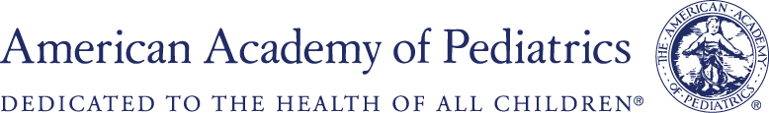
Surgical Educators Workshop
For pediatric surgery faculty… limited to the first 30 registrants
Friday, January 14, 2022
7:00 am Pacific; 8:00 am Mountain; 9:00 am Central; 10:00 am Eastern

10:00 AM (EST) Welcome
Andrew Davidoff, MD, AAP Section on Surgery Immediate Past Chair
10:10 AM Logistics –Samuel M. Alaish, MD, FAAP
10:15 AM Adult Learning, Feedback and Autonomy – David Powell, MD, FAAP
11:00 AM Panel: Teaching Audiences of Diverse Educational and Cultural Backgrounds
Teaching Different Levels of Training and Specialties - Marion Henry, MD, FAAP
Engaging Underrepresented-in-Medicine Learners - Raquel Gonzalez, MD, FAAP
11:30 AM Questions & Answers
12:00 PM BREAK
12:30 PM Panel: Teaching in Various Environments
Teaching in the Operating Room – Alfred Chahine, MD, FAAP
Teaching in the Clinic and on Rounds – Janice A. Taylor, MD, FAAP
Simulation – Seth Goldstein, MD, FAAP
1:15 PM TEACHING PERSPECTIVES BREAKOUT
Benjamin Zendejas-Mummert, MD, FAAP
Alfred Chahine, MD, FAAP
Adam Alder, MD, FAAP
2:15 PM Teaching the Difficult Learner - Samuel M. Alaish, MD, FAAP
2:30 PM Pearls from the 2020 AAP Arnold M. Salzberg Mentorship Award Winner Richard Ricketts, MD, FAAP
3:00 PM Closing Remarks and Evaluations - Samuel M. Alaish, MD, FAAP

