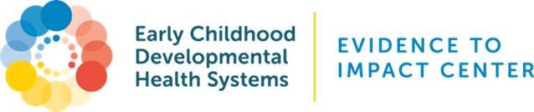
Transforming Pediatrics for Early Childhood
Cross-Sector Engagement Tool

The early childhood care continuum (promotion, family-engaged developmental monitoring and screening, care coordination & linkage, intervention) happens on two levels: both within the medical home, which provides near universal access to young children before they reach school-age, and on the broader early childhood system level comprised of multiple other programs, systems and stakeholders that can support young children and their families. Both levels rely on one another to sustain strong and comprehensive approaches along the care continuum, particularly for referral and linkage.

The below tool was adapted from Help Me Grow and the EnAct! Framework and lists different stakeholders, inclusive of “traditional” early childhood stakeholders like early care and education, and “non-traditional” stakeholders such as community-based organizations that do not focus on early childhood but do have strong relationships with families. Depending on your catchment area, these types of stakeholders may be combined, not exist, or not fully represent the breadth of potential partnerships; please edit as appropriate. There are columns for multiple considerations, including the value proposition for both parties, and potential barriers to be addressed. For the “level of partnership” dropdown options, please refer to the below chart to accurately assess where the partnership currently stands:
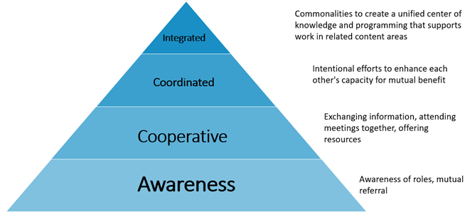
Relationship-building takes time. Start with 1-3 partnerships—either new or that can be strengthened—and identify strategies to work together to meet mutual goals.
Type of Stakeholder | Entity/Entities | What level of partnership do you currently have with them? | What benefit to YOUR ENTITY/INITIATIVE would/does this partnership have? | What benefit to the PARTNER would/does this partnership have? | Barriers to Partnership | Notes
*Family Support, Community-Based Organizations
2-1-1/United Way Chapters |  | Choose an item.
Child advocacy groups |  | Choose an item.
Cultural/local organizations |  | Choose an item.
Family support organizations |  | Choose an item.
Faith-based communities |  | Choose an item.
Foundations |  | Choose an item.
Parents, Family Leaders |  | Choose an item.
Specialized Call Centers |  | Choose an item.
*State, County, City, and Local Programs Important to Child Health
Children and Youth with Special Health Care Needs Program (CYSHCNs)/(Title V) |  | Choose an item.
Child Care Resource and Referral (CCR&Rs) |  | Choose an item.
Early Childhood Comprehensive System Grant (ECCS) |  | Choose an item.
Head Start/Early Head Start |  | Choose an item.
Help Me Grow |  | Choose an item.
Home Visiting Programs, including Maternal Infant and Early Childhood Home Visiting (MIECHV) |  | Choose an item.
IDEA Part B (intervention for 3-5) |  | Choose an item.
IDEA Part C (intervention for 0-3) |  | Choose an item.
Medicaid |  | Choose an item.
State/local Health Department |  | Choose an item.
State/local Child Welfare Agency |  | Choose an item.
*Health Care System
Hospitals |  | Choose an item.
Mental Health/Infant Mental Health |  | Choose an item.
Physician/Child Health Care Provider Champions |  | Choose an item.
Physician outreach/improvement programs |  | Choose an item.
State/local chapter of the American Academy of Pediatrics |  | Choose an item.
Universities/Medical Centers |  | Choose an item.
*Please note that entities may be listed in categories not relevant for your region/state. Please reorganize accordingly!
ACKNOWLEDGEMENTS: Thank you to the Help Me Grow National Center. This resource was adapted from Help Me Grow resources and the EnAct! Framework Partnership Landscape Analysis.

