Safety and Injury Prevention in Early Care and Education Settings
How to Register and Access the Online PediaLink Courses

- Go to https://shop.aap.org/keeping-children-safe-injury-prevention-in-early-care-and-education-settings/ and click on Register. Note that there is no cost for this online module.
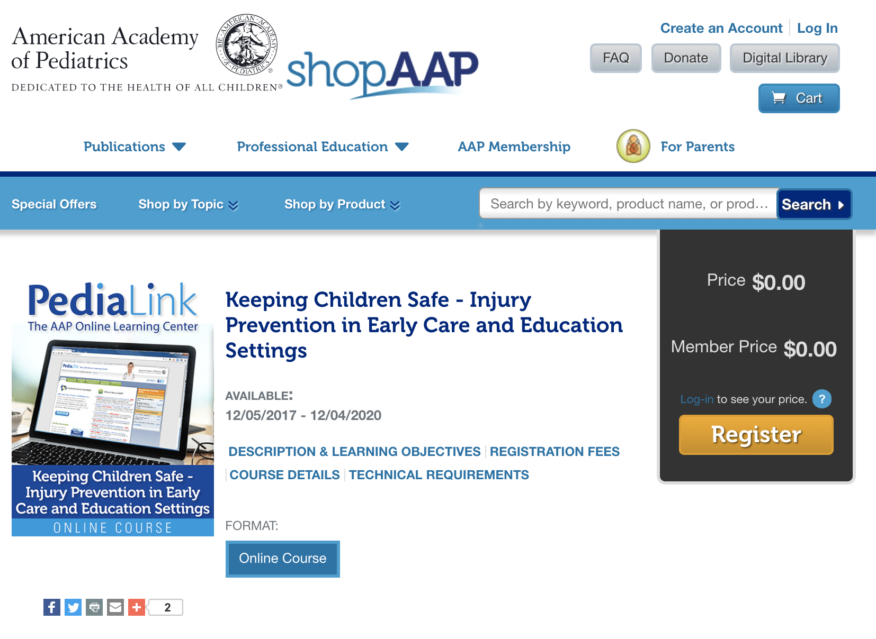
Note that if you are accessing this course from a mobile device the website may appear like the following: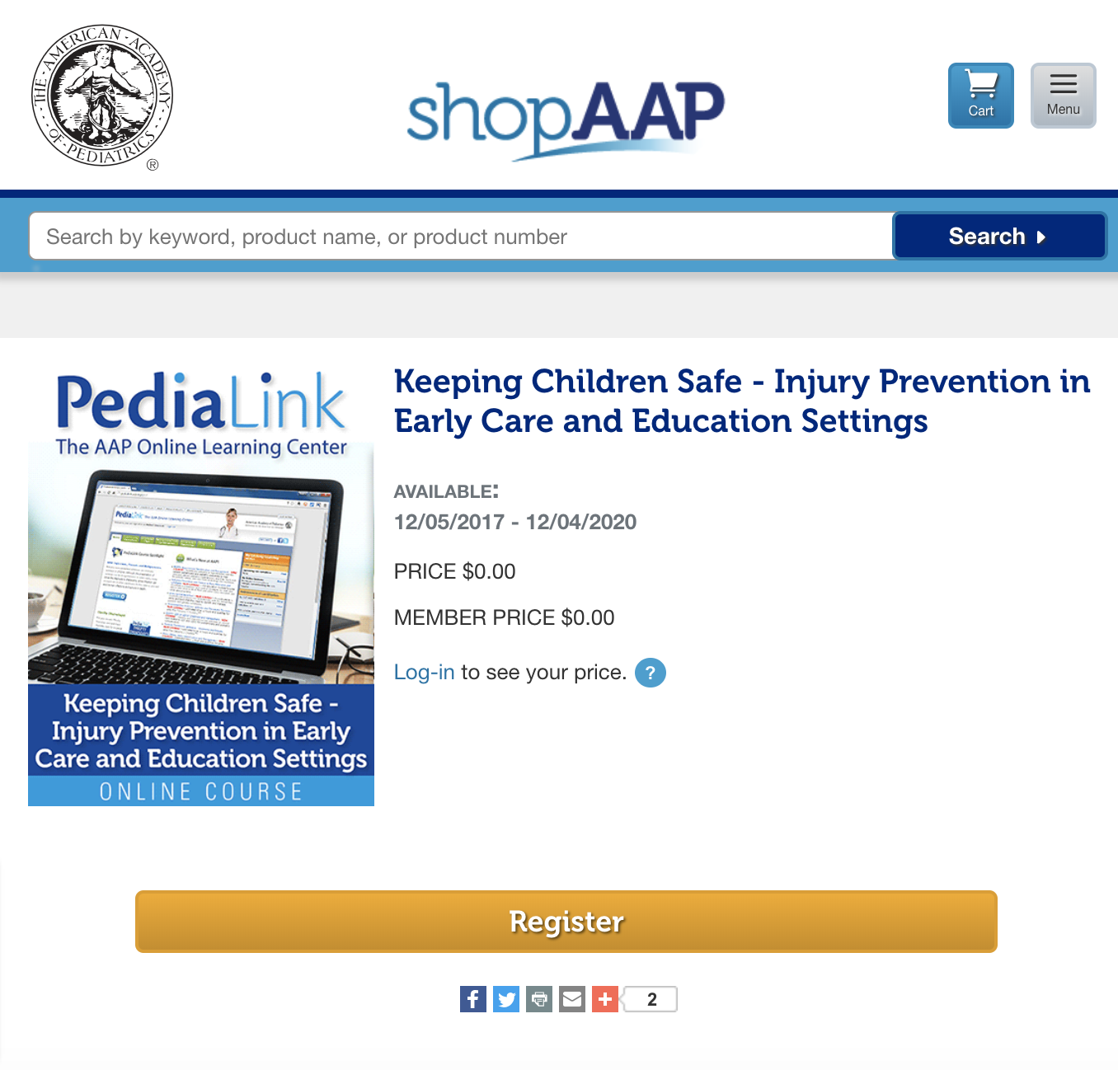

- When you click register the following screen will appear. Click Checkout: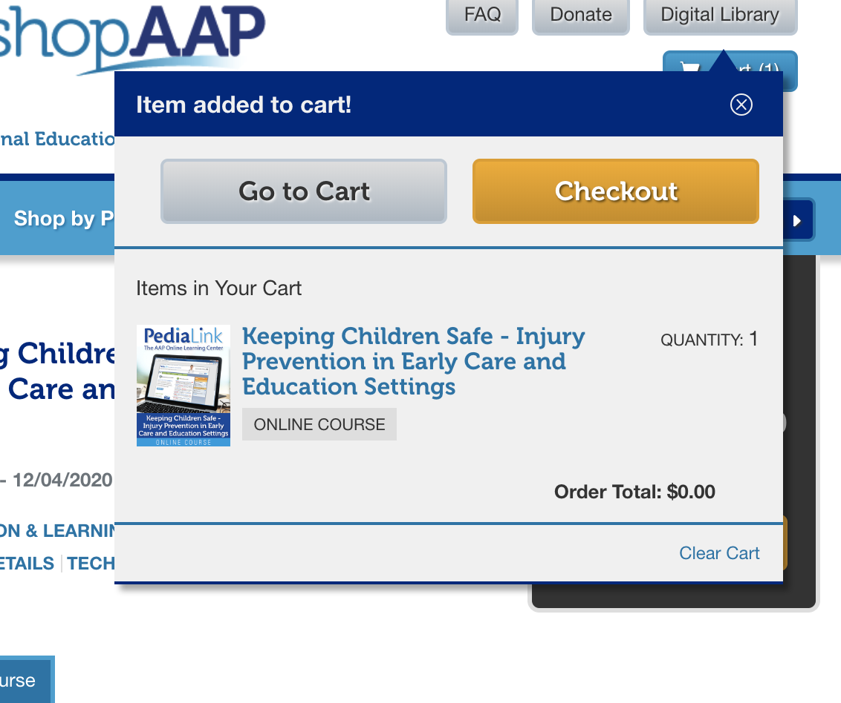

- You will be asked to log-in or create an account on a screen that looks like this. If you do not have an account click on create an account: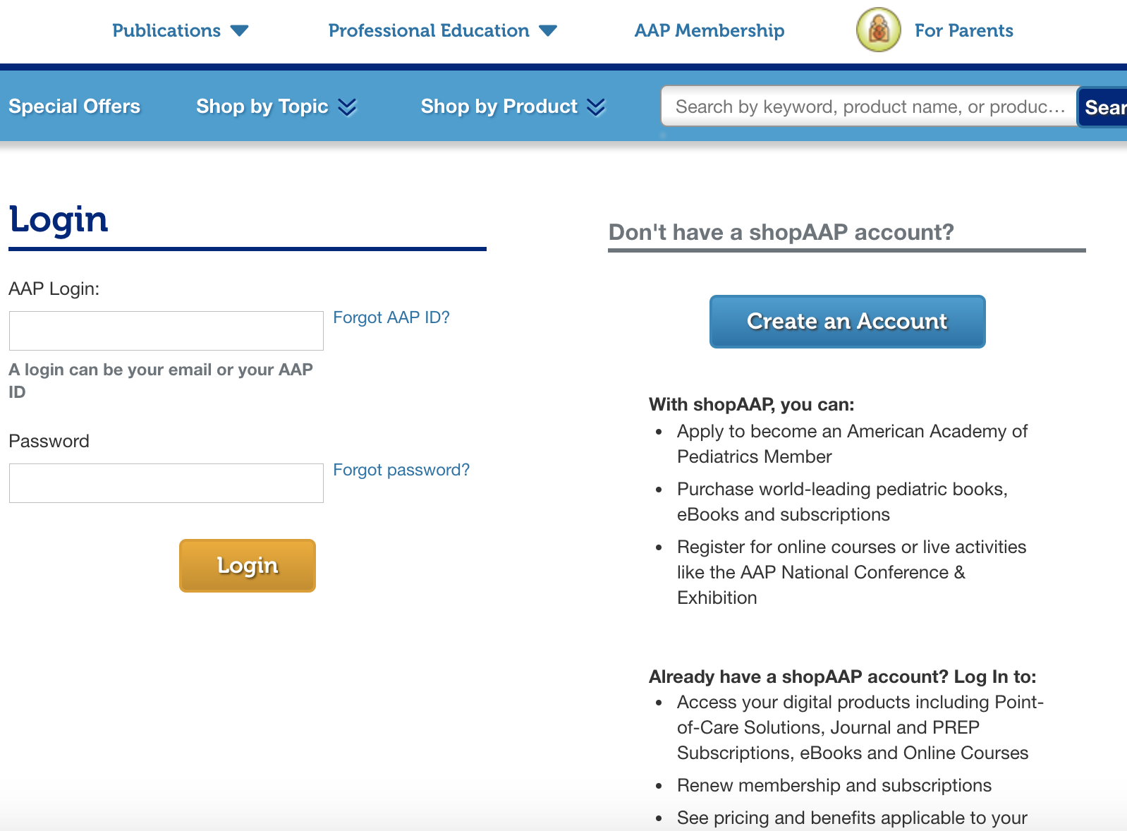
Follow the steps to create an account. When it asked to select an account type select individual as shown below, fill out the additional information and click continue:
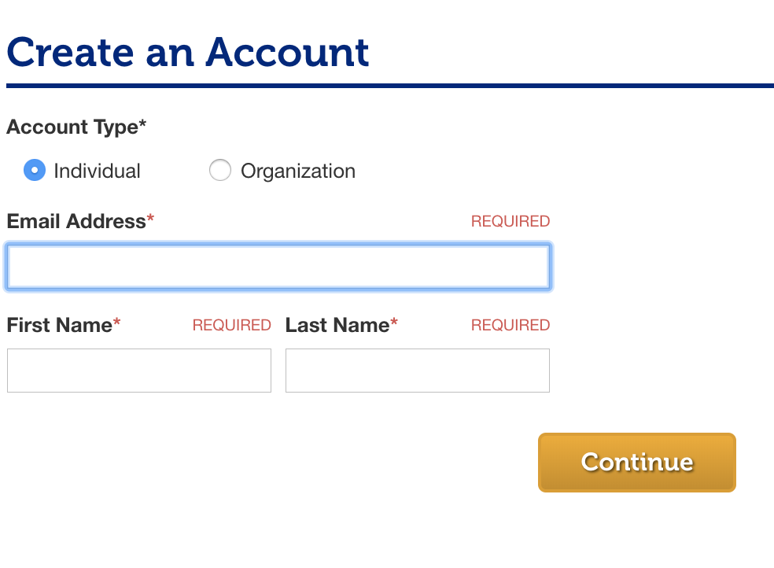
Once you have created an account, click Checkout again in My Cart.
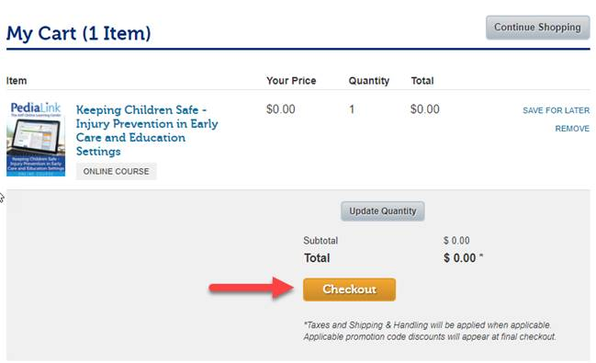

On the next screen click on place order. 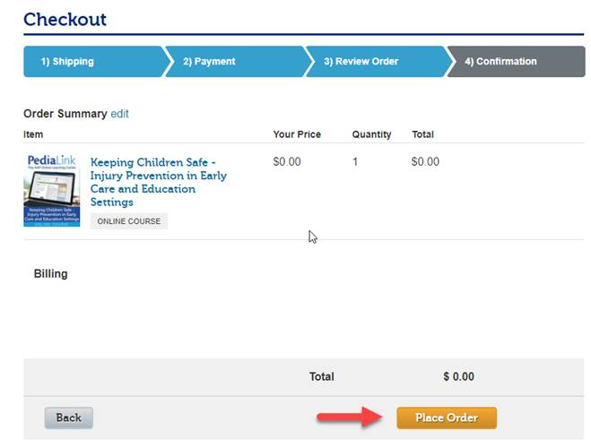

- Once your order is completed a screen will appear with confirmation of your order. The following information will also appear. If you would like to view the course click on View My Continuing Education.

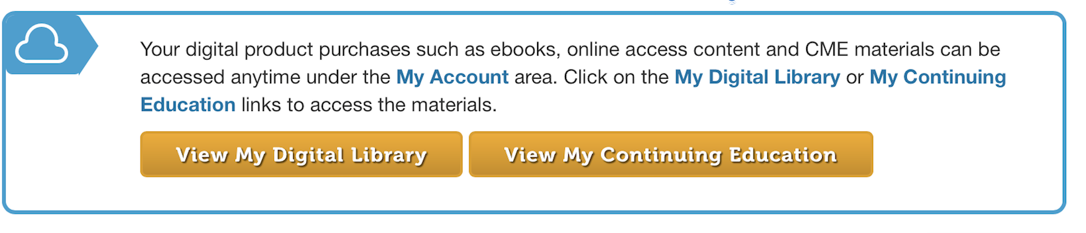
- You will also receive an email with information on how to log-in to the online course. This information can be used anytime you would like to access the course.

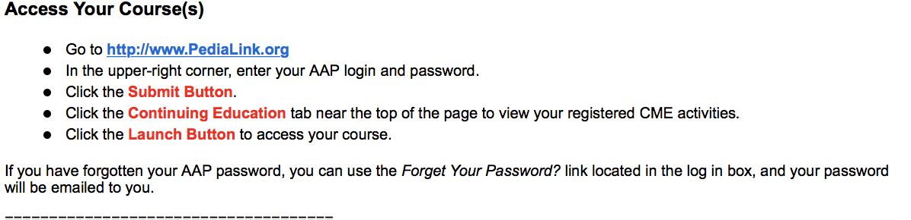

You will see a screen like the one below when you click on the continuing education tab near the top of the page to view your CME activities. Click on open to access your course.

