How to Create a Medication Doll (Bright Idea Showcase Example)
Your Name, Your Professional Credentials
Your Hospital, City, State/or Your Institutional Affiliation

Introduction
- Most newborns respond quickly to positive-pressure ventilation and medication is rarely required. Because medication administration is performed infrequently, it is critical to provide practice opportunities.
- Educational goal: provide a reusable and cost-effective method for resuscitation team members to practice UVC placement and medication administration.
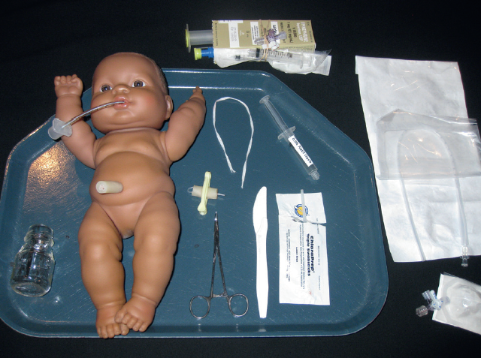
A low-cost plastic doll was outfitted with an endotracheal tube for intratracheal epinephrine administration and a re-usable umbilicus for placing an emergency umbilical venous catheter/administering epinephrine.

Description
- Cut a hole in the mouth to hold an endotracheal tube.
- Cut a small hole in the back of the doll’s head to allow moisture to evaporate after intratracheal epinephrine.
- Reusable umbilical cord: cut 2 umbilical segments – one that is about 4 cm long and another a bit longer. Insert the thin plastic zip tie (cable tie) through one arterial vessel to join both segments. Place a cord clamp about one-third from the top of the longer segment. The clamp holds the zip tie in place and simulates the portion of the umbilical cord that is cut and “discarded” prior to insertion of the umbilical catheter.
- Insert the reusable umbilical segment into the abdomen.
- Cut a hole in the doll’s back that fits over the container of simulated blood. Place the doll carefully over the blood container and ensure that the end of the umbilicus is inside the container of blood.
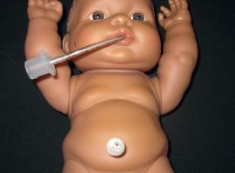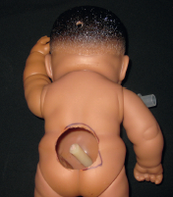

Observations
Team members were able to practice skills with the medication doll in the staff lounge (24/7 access) by using the textbook instructions or video. It is durable, requires little maintenance, and is relatively easy and inexpensive to replace.
We discovered it was necessary to secure the doll to the work surface with tape across the doll’s chest to discourage learners from lifting the doll and spilling the bottle of “blood.”

Discussion
Assisting/placing an umbilical venous catheter and administering epinephrine is a low volume, high risk procedure. Unlike an expensive newborn manikin or simulator, this medication doll could be stationed in a conference room or staff lounge to allow 24/7 access by neonatal resuscitation team member because it is durable, requires little maintenance, and is relatively easy and inexpensive to replace.

References
“Create a Medication Performance Skills Station – Method 2.” The NRP Instructor Toolkit, American Academy of Pediatrics, May 2016, https://communities.healthstream.com/docs/DOC-2916

