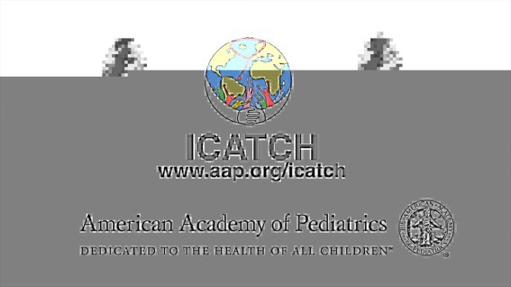
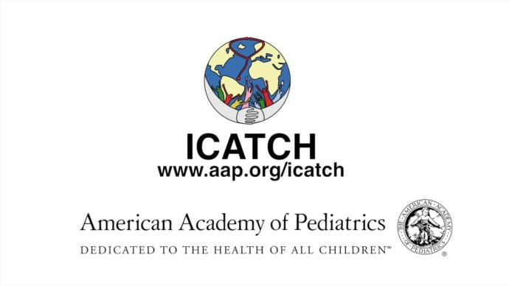

ICATCH
International Community Access to Child Health Grant Program

Preliminary Application Form

The first step in applying for ICATCH funding is to complete this
PRELIMINARY APPLICATION FORM, required of all those seeking funding in the 2018 Grant Cycle
$2000/year starting July 1, 2018 through June 30, 2021

Please carefully read the instructions on this page before completing the form.
Answer all questions in the space provided.

Please complete and submit this form by Tuesday, November 28, 2017
After review, we will inform you via email in early January 2018 if you have been selected to apply and complete the full ICATCH Application, due on March 6, 2018.
----------------------------------------------------------------------------------------------------------------------------------------

Eligibility to Apply
- Projects must be carried out in low income or low-middle income countries; see list of countries in the 2017-2018 Call for Proposals which can be found on the ICATCH website www.aap.org/icatch.
- The Project Director must live and work in or near the community where the project activities take place and take primary responsibility for direction and completion of the project. The Project Co-Director may live elsewhere, including in a different country, as long as he/she is actively involved in the project.
- The idea for the proposal should originate from the community where the project will take place.

General Instructions
- Before completing this form, you must read the 2017-2018 Call for Proposals on the ICATCH website www.aap.org/icatch
- Keep your proposed project simple. Do not plan to do too much. We look more favorably on a simple proposal with a high likelihood of success than a complicated proposal that runs a risk of not being completed as planned. PLEASE DO NOT SEND US ADDITIONAL ATTACHMENTS.
- Your idea does not have to be worked out completely at this stage, but you must be able to clearly and concisely describe what you would like to do.
- It is very important that all those who will be involved with implementing your project be brought in on the planning at this stage. For example, if you will be working with community health workers, or teachers, you should confirm their interest and ability to participate now, and seek their input in this early planning stage.
- ICATCH does not fund research proposals. We fund proposals that improve or provide clinical care for children/adolescents, training for health providers, and health education for children, parents and teachers. We do require evaluation of project outcomes.
- Please use font size no smaller than 11; limit answers to space provided in white text boxes. To determine word count/character count, highlight your text, click on “Tools” then “Word Count.” APPLICATIONS LONGER THAN THE 2 PAGES BELOW WILL NOT BE CONSIDERED.

Please email this PRELIMINARY APPLICATION FORM to icatch@aap.org no later than
TUESDAY, NOVEMBER 28, 2017.
If you do not receive an email from ICATCH confirming receipt of your form within 48 hours of submission, please email us again.
We look forward to hearing about your proposal!

One Sentence Summary of Your Proposal (40 words max):

1. Briefly describe your proposal, to be carried out over 3 years.
What is your goal(s)? Tell us what you want to do and why this is needed; how you will do it; where the activities will take place and what the community is like; who will carry out the activities; the approximate time frame and frequency of activities, and any outcomes you would measure including an estimation of how many children/families/trainees would be affected (2250 characters max, not counting spaces):

2. Project Director (must live and work near the community where project will take place)
First & last name; degree/title (if any); email address; type of work done by this person in general; and a few sentences about what this Director will do specifically related to this project (500 characters max, not counting spaces):

3. Project Co-Director
First & last name; degree/title (if any); email address; type of work done by this person in general; and a few sentences about what this Co-Director will do specifically related to this project (500 characters max, not counting spaces):

Page 1

4. What will the $2000 per year grant be used for during each of the 3 years?
Please be as specific as possible (1000 characters max, not counting spaces):

5. Are the personnel or groups involved in this proposal affiliated with an institution, existing health center, nongovernmental organization (NGO), nonprofit or other organization? If so, please describe the relationship and provide website of the organization, if there is one (500 characters max, not counting spaces):

6. Is there anything else you would like to tell us about your proposal? You may want to mention past successes, partners you will work with, plans for sustainability beyond the grant period, why this is very much needed, the difference it will make, etc. This information may help us select your proposal to be included among those invited to apply for funding in the 2018 Grant Cycle (500 characters max, not counting spaces):

7. Person(s) writing and submitting this PRELIMINARY APPLICATION FORM. If not the Director or Co-Director, please tell us who you are, your email and your relationship to the proposed project (500 characters max):

Please email this PRELIMINARY APPLICATION FORM to icatch@aap.org no later than TUESDAY, NOVEMBER 28, 2017. If you do not receive an email from ICATCH confirming receipt of your form within 48 hours of submission, please email us again!
We look forward to hearing about your proposal!

Page 2

